Angular Route Guards
Angular Route Guards are interfaces provided by the Angular Router that allow developers to control navigation to & from routes. Guards help enforce authentication, authorization, data validation, & pre-loading requirements before the route is activated.
Route guards do not provide security on the server side; they only control navigation within the Angular application. Real security must be always implemented on the server side (backend).
Why use Route Guards?
Common use cases for Route Guards:
- Restricting access to authenticated users.
- Implementing role-based authorization.
- Preventing users from leaving a page with unsaved changes.
- Loading required data before a component is displayed.
- Controlling access to the child routes.
Types of Angular Route Guards
- CanActivate Guard
Purpose of CanActivate Guard
The CanActivate Guard determines whether a route can be activated or visited.
Before Angular loads a component associated with a route, it executes the CanActivate guard.
Possible results for CanActivate Guard execution:
  - true -> Navigation continues.
  - false -> Navigation is cancelled.
  - UrlTree -> User is redirected to another route.
- CanActivateChild Guard
Purpose of CanActivateChild Guard
The CanActivateChild Guard controls access to child routes of a parent route.
Instead of applying the same guard to every child route, Angular allows a single guard for all child routes.
- CanDeactivate Guard
Purpose of CanDeactivate Guard
The CanDeactivate Guard prevents navigation away from a route.
It is commonly used for:
  - A form contains unsaved changes
  - A transaction is incomplete
  - User confirmation is required before leaving.

- Resolve Guard (Resolver Guards)
Purpose of Resolve Guard
A Resolver loads data before a route is activated.
Rather than loading the data after the component appears, Angular waits for data retrieval & then loads the component.
Why use Resolver?
Without Resolver:
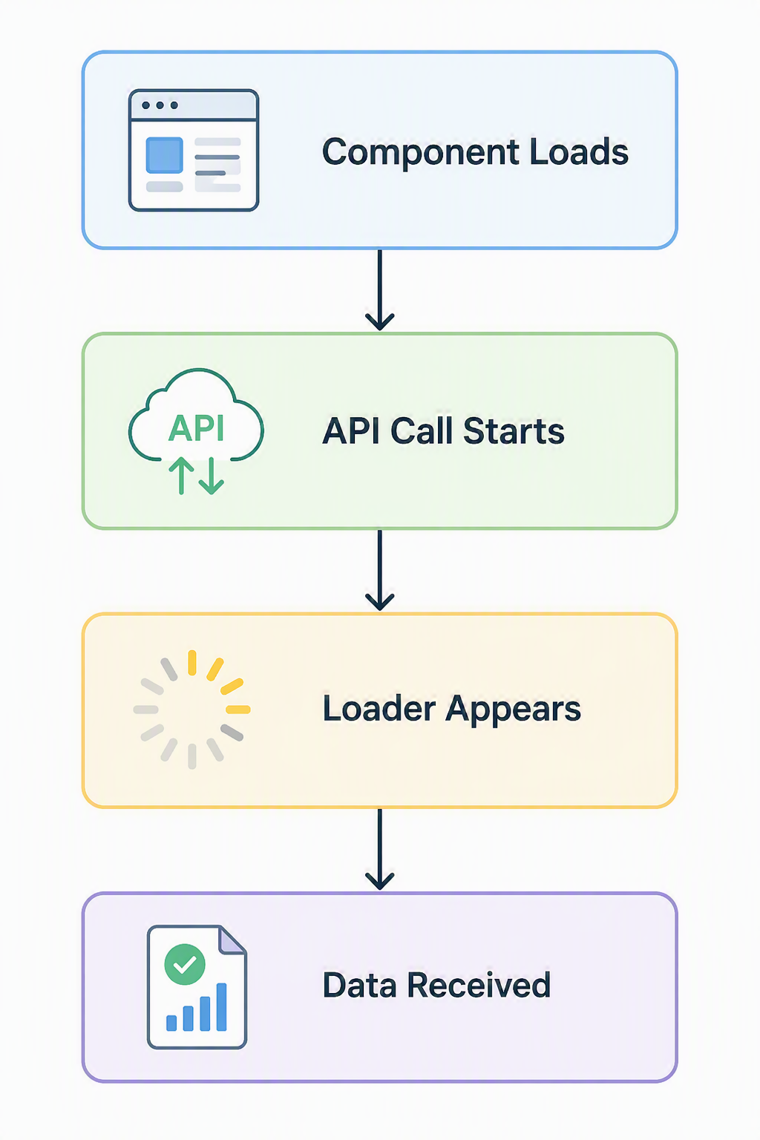

With Resolver:
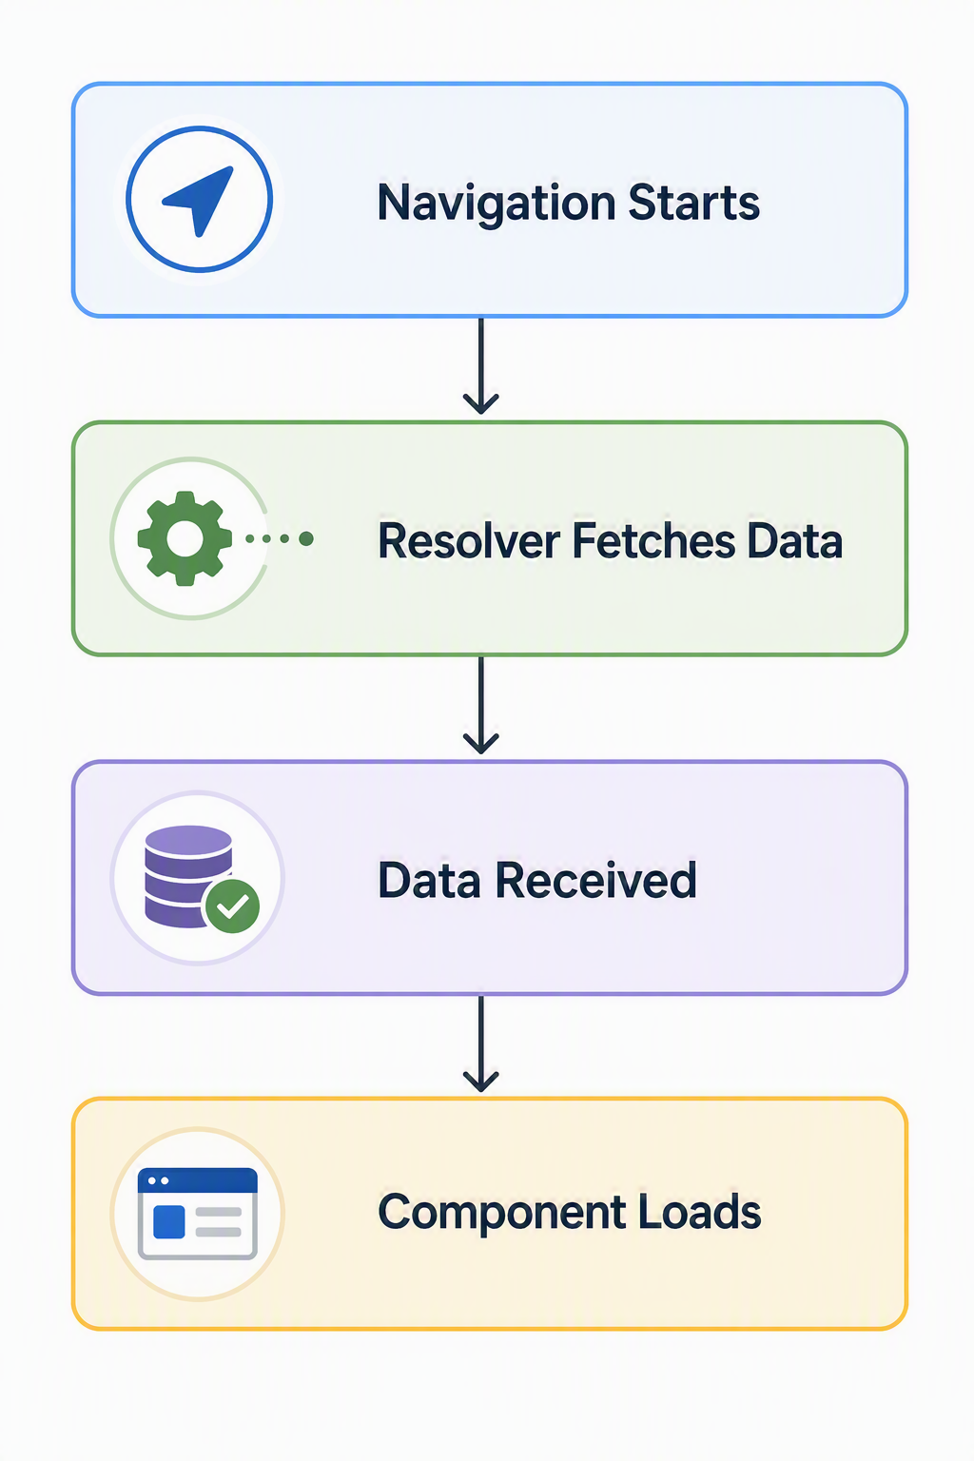

- CanMatch (newer Angular versions)
- Purpose of CanMatch Guard
CanMatch is a Route Guard that decides whether a route configuration should be considered a match during route navigation.
Unlike CanActivate Guard which runs after Angular has matched a route, CanMatch Guard runs before route matching is finalized. This makes it ideal for controlling access to lazy-loaded components, feature flags, role-based routing & route selection.
Why Angular introduced CanMatch Guard?
Older Angular applications commonly used CanLoad to prevent lazy-loaded modules from loading.
However, CanLoad had limitations:
  - It only worked with lazy-loaded routes
  - It completely blocked routing
  - It couldn’t easily allow Angular to try alternative routes.
Hence, Angular introduced CanMatch Guard as a more flexible replacement.
Using Bootstrap in Angular

